
Software Engineering Department
Capstone Project Phase B

MsgGuard - Generative AI for Phishing Detection and Prevention

Github: https://github.com/Eleia522000/phishing-ai-detector

Supervisor: Dr. Reuven Cohen

Submitted by:

Name Eleia Elias Enab Fouad
ID 208173021 212697239
E-mail Eleia.elias@e.braude.ac.il Enab.fouad@e.braude.ac.il

Table of Contents
Contents
Abstract 4
1. Problem and Background 4
1.1 The Problem 4
1.2 Short Literature and Technology Background 5
1.3 Existing Solutions and Limitations 5
1.4 Project Need 5
1.5 Stakeholders 6
1.6 Project Scope 6
2. General Description of the Implemented System 6
2.1 System Goal 6
2.2 Target Users 6
2.3 Implemented Features 6
2.4 Implemented Requirements 7
2.5 System Components 7
3. Implemented Solution 8
3.1 High-Level Architecture 8
3.2 Backend API 8
3.3 URL Extraction and Preprocessing 9
3.4 BERT-Based AI Component 9
3.5 Identity-Based Verification Components 9
3.5.1 Domain Age Verification 9
3.5.2 IP Geolocation Check 9
3.5.3 Brand-Domain Matching 10
3.6 Decision Logic 10
3.7 User Interface 11
3.8 System Output and Explanation 12
4. Engineering Development Process 13
4.1 Development Stages 13
4.2 Tools and Technologies Used 13
4.3 Dataset and Model Training 13
4.4 Backend Implementation 14
4.5 Mobile Application Implementation 14
4.6 Integration 14
4.7 Project Structure 14
5. Challenges, Decisions, and Solutions 15
5.1 Technical Challenges 15
5.2 Design Decisions 15
5.3 Limitations 15
5.4 Lessons Learned 16
6. Verification and Evaluation 16
6.1 Verification Testing 16
6.2 Verification Test Cases 16
6.3 BERT Model Evaluation Results 17
6.4 Full System Quantitative Results 18
6.5 Conclusions From the Evaluation Results 19
7. Project Conclusions 20
8. References 20
Appendix A - User Guide 21
A.1 Introduction 21
A.2 How to Analyze a Suspicious Message or URL 21
A.3 Understanding the Result 21
A.4 User Help 22
Appendix B - Maintenance Guide 22
B.1 System Environment 22
B.2 Running the Backend 22
B.3 Running the Mobile Application 22
B.4 Updating the System 23
B.5 Recommended Future Maintenance 23

Abstract
Phishing remains one of the most damaging cyber threats because attackers imitate trusted brands, use urgent wording, and create domains that look similar to legitimate services. The Phase B implementation of MsgGuard addresses this problem through a practical Android application connected to a Flask backend. The system analyzes suspicious messages and URLs by combining a fine-tuned BERT model with identity-based verification checks.
The implemented solution uses BERT as the main AI classifier and adds three explainable identity checks: WHOIS-based domain age verification, IP geolocation analysis, and brand-domain matching. These checks are not used as independent final decisions. Instead, they provide supporting evidence that is combined with the model output in the final decision stage. This design helps the system remain understandable for non-technical users while still using machine-learning-based detection.
The final Phase B product includes the Android user interface, the backend analysis API, trained model files, identity-checking modules, decision logic, testing scenarios, a user guide, and a maintenance guide. The current quantitative results reported in this document refer to the BERT model evaluation only. The full hybrid pipeline is described as an implemented system, while its complete end-to-end quantitative evaluation is listed as a recommended future evaluation step.

1. Problem and Background

1.1 The Problem
Phishing attacks attempt to convince users to trust malicious messages, fake websites, or misleading links. Attackers often imitate banks, online stores, delivery companies, social-media platforms, and technology services. They use urgent language, fake login requests, account-lock warnings, prize messages, and domains that visually resemble official brand domains. This makes phishing difficult for ordinary users to identify, especially on mobile devices where URLs are harder to inspect.
Traditional detection methods such as blacklists are useful for known phishing sites, but they are weak against newly created domains and zero-day phishing attempts. A phishing domain can be registered, used for a short attack campaign, and removed before it becomes widely reported. For this reason, relying only on known malicious domains is not enough for a practical mobile tool.
Machine-learning models can detect suspicious patterns in messages and URLs, but they also have limitations. A model may perform well on a dataset and still miss attacks that use new wording, unfamiliar domains, or brand impersonation techniques not represented in the training data. MsgGuard was therefore designed as a hybrid system that combines AI classification with identity-based checks.

1.2 Short Literature and Technology Background
Previous phishing-detection approaches include rule-based filters, classical machine-learning models, and deep-learning models. Rule-based methods check visible URL features or compare links against known malicious lists. Classical models such as Logistic Regression, Random Forest, and SVM use engineered features such as URL length, number of special characters, domain structure, and known suspicious terms. Deep-learning approaches can learn richer patterns directly from text or URL sequences.
Transformer-based language models such as BERT are especially useful for phishing-message detection because they analyze context rather than isolated words. A phishing message may appear legitimate when looking only at individual words, but the full sentence can contain suspicious intent, urgency, pressure, or requests for sensitive information. BERT helps capture these contextual signals.
Identity-based verification complements AI classification. Domain age, hosting origin, and brand-domain similarity can reveal information that is not always visible from message text alone. For example, a message may look normal but lead to a domain that was registered recently or to a domain that imitates a known brand name. This combination supports both detection and explainability.

1.3 Existing Solutions and Limitations
Existing phishing protection solutions include email filters, browser warnings, security gateways, and browser extensions. These solutions are important, but they do not always match the way users interact with suspicious content on mobile devices. A user may receive a suspicious SMS, WhatsApp message, or social-media link and need a quick explanation before deciding whether to open it.
Another limitation is explainability. Some systems only return a safe or unsafe label without explaining why the content is risky. For non-expert users, a short explanation is useful because it helps them understand the reason behind the warning. MsgGuard focuses on returning a classification together with readable reasons such as suspicious wording, a recently registered domain, brand mismatch, or hosting-origin inconsistency.

1.4 Project Need
The need for MsgGuard comes from the gap between high model accuracy on datasets and real-world phishing behavior. A mobile user needs a simple tool that can quickly analyze suspicious content and return an understandable result. The system therefore focuses on practical detection, clear explanations, and a workflow that fits normal mobile use.
The project implementation also supports an engineering need. The analysis process is divided into separate components: AI classification, domain age verification, IP geolocation checking, brand-domain matching, and final decision logic. This structure helps the system give users a clearer result because the final decision is based on both the AI classification and several explainable identity indicators.

1.5 Stakeholders
- Mobile users who receive suspicious SMS, WhatsApp, email, or social-media messages.
- Organizations and brands affected by impersonation and fake login pages.
- Cybersecurity teams that need additional explainable phishing indicators.
- Future developers who may extend the system with more detection modules or deployment options.

1.6 Project Scope
The scope of Phase B was to implement a working prototype, not a complete commercial security product. The system demonstrates an end-to-end flow from user input in the mobile app to backend analysis and user-facing result. It does not replace enterprise anti-phishing systems, browser warnings, or email gateway protection. Instead, it provides a practical mobile-focused prototype that combines AI detection with explainable identity checks.

2. General Description of the Implemented System

2.1 System Goal
MsgGuard was implemented as a phishing-detection system for mobile users. The user submits a suspicious message or URL through the mobile app. The app sends the input to the Flask backend, where the content is analyzed using the BERT model and identity-based checks. The backend returns a label, a risk score, and explanatory reasons that are displayed to the user.
The system goal is not only to classify the input, but also to help the user understand the result. A warning without context may be ignored, while a warning with concrete reasons can support safer behavior. For that reason, the output includes both the technical classification and short user-readable explanations.

2.2 Target Users
The system is intended for non-expert mobile users. The user is not expected to understand domain registration, IP geolocation, WHOIS records, or machine-learning models. The interface therefore presents the result in simple language and gives clear reasons such as a recently registered domain, brand mismatch, or suspicious message wording.

2.3 Implemented Features
- Mobile application built with React Native and Expo.
- Flask backend API that receives analysis requests and returns JSON results.
- Fine-tuned BERT model for phishing classification.
- WHOIS-based domain age verification.
- IP geolocation-based hosting-origin check.
- Brand-domain matching for detecting impersonation and misleading domain structures.
- Final decision logic that combines AI output with identity indicators.
- User-facing explanation of the main reasons behind the result.

2.4 Implemented Requirements
The implementation satisfies the main project requirements in a practical prototype form. The system accepts suspicious content, extracts URLs when they exist, analyzes the text with BERT, executes identity checks for domain-related evidence, combines the signals, and presents a clear result to the user.
Functional Requirements
- The user can submit a suspicious message or URL.
- The backend validates the submitted input.
- The system extracts URLs and domain information from the message.
- The BERT model classifies the content as phishing or legitimate.
- The system checks domain age using WHOIS information.
- The system checks hosting-origin information using IP geolocation.
- The system checks brand-domain consistency to detect impersonation.
- The system combines the results into a final classification and explanation.
Non-Functional Requirements
- Usability: the application presents the result in simple language for non-expert users.
- Explainability: the system gives short reasons behind the classification, not only a label.
- Response time: the system is designed to return the analysis quickly enough for normal mobile use.
- Reliability: the system handles normal messages, URLs, messages with embedded links, and invalid input without crashing.

2.5 System Components
The implemented system is composed of several cooperating components. The mobile application is responsible for user interaction. The backend API receives the submitted input and coordinates the analysis. The BERT model provides the main AI prediction. The identity-verification modules provide domain-level evidence. The decision logic combines all available signals into a final result.
This structure follows a clear separation of responsibilities. The frontend does not run the heavy model or perform domain analysis. Instead, it sends the suspicious content to the backend and displays the returned result. The backend contains the logic that may change over time, such as model loading, threshold decisions, domain checks, and explanation generation.

3. Implemented Solution

3.1 High-Level Architecture
The architecture contains five main stages: mobile input, backend API, AI analysis, decision logic and scoring, and user result. The mobile app sends the submitted content to the backend, where the analysis is performed. The backend then returns a final label, risk score, and explanation that are displayed clearly to the user.
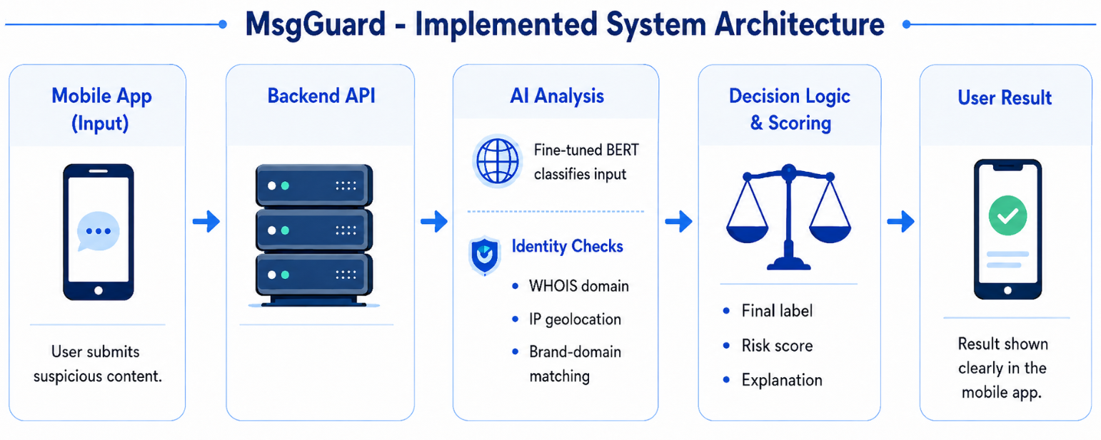
Figure 1: Implemented MsgGuard system architecture.

3.2 Backend API
The backend is implemented in Python using Flask. The main analysis endpoint receives the submitted message or URL, validates the input, extracts URLs, sends the text to the BERT model, runs identity checks when a URL is present, and returns a structured JSON response. The backend acts as the coordination layer between the mobile app, the trained model, and the supporting verification modules.
The API is designed to keep the frontend simple. The mobile app does not need to know how domain age is checked or how the model performs inference. It only sends the input and receives the final response. This design also makes it easier to improve the backend later without changing the mobile interface, as long as the returned JSON fields remain stable.
The backend response includes the final classification, risk score, risk level, and explanation. This format supports the user interface because the app can directly display the result without performing additional security analysis on the device.

3.3 URL Extraction and Preprocessing
Before running domain-related checks, the backend extracts URLs from the submitted text. If the input contains a full URL, the system identifies the domain and prepares it for WHOIS, geolocation, and brand-domain analysis. If the message does not contain a URL, the system still performs BERT-based text classification and returns a result based on the message content.
Preprocessing is important because phishing messages often contain extra text around a link. The backend must separate the message text from the URL-related evidence. This allows the AI component to analyze the full message while the identity modules analyze the domain itself. The separation also helps avoid trusting misleading subdomains that only visually contain a brand name.

3.4 BERT-Based AI Component
The AI component uses a fine-tuned BERT model to classify phishing and legitimate content. BERT was selected because phishing messages often depend on context, wording, and intent. The model can analyze full message meaning instead of relying only on simple keywords. In the implemented system, BERT provides the main machine-learning prediction, which is then used by the backend as one input to the final decision.
The model is useful for detecting wording patterns such as urgency, account verification requests, prize claims, payment warnings, and requests for sensitive information. These patterns may appear in different forms, so a contextual model is more suitable than a simple keyword list. However, the model result is not treated as the only source of truth. It is combined with identity checks to produce a more explainable final decision.

3.5 Identity-Based Verification Components

3.5.1 Domain Age Verification
The domain age module checks how long the domain has existed using WHOIS information. Recently registered domains are treated as suspicious because many phishing campaigns register domains shortly before sending attacks. Domain age is not used as a standalone decision, because some legitimate domains may also be new. It is used as one supporting risk indicator.
This module is especially useful when the message claims to come from an established organization but links to a domain that appears new. In such a case, the domain age does not prove phishing by itself, but it adds meaningful risk evidence that can support the final decision and explanation.

3.5.2 IP Geolocation Check
The IP geolocation module resolves the domain and examines hosting-origin information. If a URL claims to represent a known brand but is hosted in an unexpected location or infrastructure, the module can add risk to the final decision. The check is used carefully because legitimate brands may use cloud providers and multiple hosting regions.
For this reason, IP geolocation is treated as contextual evidence. It is not enough to mark a message as phishing only because of hosting location. Instead, it becomes more meaningful when it appears together with other indicators such as brand mismatch, suspicious wording, or a very new domain.

3.5.3 Brand-Domain Matching
The brand-domain matching module checks whether the domain is consistent with the claimed brand. It detects suspicious cases such as brand names placed in unrelated domains, misspellings, misleading subdomains, and unofficial top-level domains. This component is important because phishing attacks often rely on visual similarity to trusted brands.
For example, an attacker may place a bank name in a subdomain while the real registered domain belongs to another site. Ordinary users may notice the familiar brand name and trust the link. The brand-domain module helps reduce this risk by checking whether the brand and the actual registered domain are consistent.

3.6 Decision Logic
The final decision logic combines BERT output with identity-check indicators. The system does not rely on one signal only. A message can be suspicious because of its wording, because of the linked domain, or because several weak indicators appear together. The backend uses the combined evidence to produce a classification, a risk score, and the explanation shown to the user.
The decision flow is implemented as a sequence of analysis steps.
- Input: message or URL from the mobile app.
- Run BERT classification on the submitted text.
- If a URL exists, extract the domain.
- Run WHOIS domain age check.
- Run IP geolocation check.
- Run brand-domain matching.
- Combine the BERT result and identity indicators.
- Return the final label, risk score, and explanation.
This logic improves explainability because each decision can be traced back to a specific signal. Instead of returning only a black-box model label, the system can explain that the result was affected by suspicious wording, a recently created domain, a brand mismatch, or hosting-origin inconsistency.

3.7 User Interface
The mobile user interface was implemented with React Native and Expo. It allows the user to submit suspicious content and view the final analysis result. The main screens of the application are shown below.

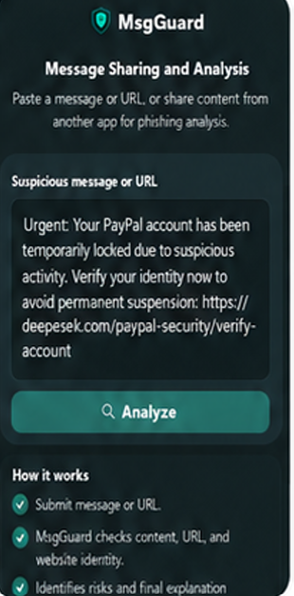
Figure 2: MsgGuard home screen.
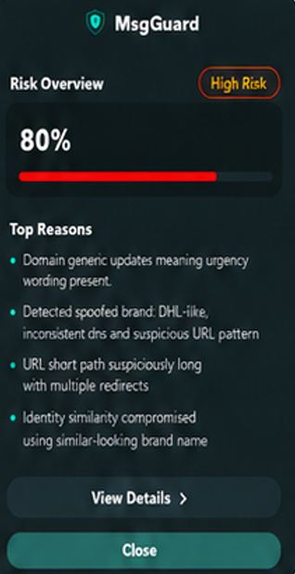
Figure 3: High-risk analysis result screen displayed after pressing the analyze button

3.8 System Output and Explanation
The output of the system is designed to be readable rather than purely technical. A user should not need to understand model probabilities or WHOIS records in order to benefit from the system. The final screen presents a label such as legitimate, suspicious, or phishing, together with a risk score and short explanation.
The explanation is important because it turns the detection result into guidance. For example, the user may be told that the message contains suspicious wording, the domain is new, the claimed brand does not match the domain, or the hosting-origin information is unusual. This helps the user understand why caution is recommended.

4. Engineering Development Process

4.1 Development Stages
The development process was carried out in several stages. First, the phishing problem and existing detection methods were reviewed. Then the dataset and model-training pipeline were prepared. After that, the BERT model was fine-tuned and evaluated. In parallel, the backend API and mobile frontend were implemented. The identity checks were added as separate modules and connected to the backend decision logic. Finally, end-to-end tests were performed to verify communication between the app and backend.
This staged process helped reduce implementation risk. The AI component could be trained and evaluated separately, while the backend and mobile application were developed around a stable request-response flow. The identity checks were then connected gradually so that each module could be tested before being used in the final decision.

4.2 Tools and Technologies Used
- Python for backend development, preprocessing, and model integration.
- Flask for the API endpoint and request handling.
- BERT and transformer libraries for text-based phishing classification.
- WHOIS lookup tools for domain age verification.
- IP geolocation service for hosting-origin analysis.
- React Native and Expo for mobile application development.
- MongoDB for storing project-related data and supporting future data management.
- VS Code and standard Python tools for implementation and testing.

4.3 Dataset and Model Training
The model-training stage used labeled phishing and legitimate samples. Legitimate domains and messages were combined with phishing samples to create a balanced dataset. The BERT model was trained to distinguish phishing from legitimate content based on textual and URL-related patterns. Training outputs included model checkpoints, final metrics, and a confusion matrix.
The dataset stage is important because the quality of the model depends strongly on the quality and balance of the training data. The model must learn patterns that appear in phishing content without simply memorizing a small group of examples. The evaluation results were therefore reported separately from the full hybrid system evaluation so the report clearly distinguishes between model-level performance and whole-system behavior.

4.4 Backend Implementation
The backend was implemented as a Flask application. It receives requests from the mobile app, validates the input, calls the BERT model, executes identity modules, and formats the final response. The backend returns structured information, including the final classification, risk score, and explanation fields.
The backend is the central part of the implemented solution because it coordinates all analysis components. It must handle normal messages, URLs, messages with embedded links, and invalid input. It must also keep the response format stable so that the frontend can display results without needing to know the internal details of the model or identity checks.

4.5 Mobile Application Implementation
The mobile application was implemented using React Native and Expo. The app provides the user-facing interface and communicates with the backend API. The mobile side focuses on simplicity: the user submits suspicious content, the app sends the request, and the result is displayed in a clear format.
The mobile interface was designed for non-technical users. It avoids exposing raw technical values unless they are useful for understanding the result. The main goal of the interface is to support quick decision-making: the user should be able to understand whether the content appears legitimate, suspicious, or phishing.

4.6 Integration
Integration focused on connecting the mobile application with the Flask backend and ensuring that backend responses are displayed correctly. The backend needed to return consistent JSON fields so the frontend could present the classification and explanation without requiring additional processing on the device.
Integration testing also helped verify that the user-facing flow worked as expected. The system needed to accept input, call the backend, wait for analysis, receive the response, and display the correct result. This step is important because individual modules can work correctly while the complete system still fails because of mismatched fields, incorrect endpoint configuration, or network issues.

4.7 Project Structure
The repository structure separates the backend, mobile application, model-related files, and documentation. This organization is important because the project combines mobile development, backend development, machine-learning integration, and identity-verification logic.
The backend area contains the Flask application, analysis endpoint, model-loading logic, and identity-checking modules. The mobile application area contains the React Native interface and API communication code. Model-related files and evaluation outputs are kept separately to make future updates easier.

5. Challenges, Decisions, and Solutions

5.1 Technical Challenges
Several technical challenges appeared during implementation. The first challenge was combining AI output with identity checks in a way that remains understandable. The solution was to keep the components separate and combine their outputs only in the final decision stage. This makes the system easier to debug and explain.
A second challenge was avoiding over-reliance on domain age. Recently registered domains are often suspicious, but new legitimate domains also exist. The solution was to treat domain age as a supporting signal rather than a final decision by itself.
A third challenge was improving robustness against phishing attempts that differ from samples seen during training. AI models may perform well on known patterns but struggle with newly created domains or brand impersonation attacks. To reduce this limitation, identity-based verification components were added to complement the BERT model and provide additional evidence for the final decision.

5.2 Design Decisions
The main design decision was to combine AI classification with identity-based verification checks instead of relying on one method only. The AI model analyzes the submitted message or URL text, while the identity checks provide additional domain-level evidence such as domain age, IP geolocation, and brand-domain consistency.
Another important design decision was to treat each identity check as supporting evidence rather than as a final decision by itself. This was especially important for domain age, because a recently registered domain can be suspicious, but a new domain can also be legitimate.
The final decision is based on the combination of several signals. This design helps the system produce a more balanced result and allows the user to receive a clearer explanation, such as suspicious wording, new domain, brand mismatch, or unusual hosting-origin information.

5.3 Limitations
The current implementation is a practical prototype, and some limitations remain. The quantitative evaluation reported in this document measures the BERT model only. The complete hybrid system should be evaluated by sending labeled test inputs through the same Flask endpoint used by the mobile application. This would measure the final behavior of the full system rather than only the model.
Another limitation is that some phishing attempts may use wording, domains, or impersonation methods that were not represented in the training data. The identity-based checks reduce this limitation, but they do not remove it completely.
Brand-domain matching also depends on the quality and coverage of the brand-reference list. If a brand is missing from the list, the system may not detect that specific impersonation attempt. IP geolocation also has limitations because legitimate companies may use cloud providers and multiple hosting regions. For this reason, geolocation is treated only as supporting evidence.

5.4 Lessons Learned
- Combining AI classification with identity-based checks improves explainability because users receive reasons, not only a label.
- Identity checks should be treated as supporting evidence rather than absolute proof.
- Domain age is useful, but it must be handled carefully because not every new domain is malicious.
- AI model results should be supported by additional indicators because phishing attacks can change over time.
- End-to-end evaluation of the complete system is important because model-level performance alone does not fully represent the final user-facing result.
- A stable backend response format is important because the mobile application depends on consistent fields such as classification, risk score, risk level, and explanation.

6. Verification and Evaluation

6.1 Verification Testing
Verification focused on checking whether the implemented system behaves correctly in representative user scenarios. Each scenario checks both the classification result and the explanation returned to the user. This is important because the system is not only expected to classify input, but also to explain the result in a way the user can understand.
The verification process included scenarios for legitimate URLs, phishing URLs, brand impersonation, misleading subdomains, messages without URLs, and invalid input. These scenarios check that the system does not crash, that it returns a structured result, and that the explanation is connected to the detected risk indicators.

6.2 Verification Test Cases
- Legitimate URL: the system recognized official domains and avoided unnecessary warnings.
- Phishing URL: the system classified suspicious input as phishing or suspicious.
- Recently registered domain: the system identified domain age as a risk indicator when relevant.
- Brand impersonation: the system detected mismatch between the claimed brand and the real domain.
- Misleading subdomain: the system extracted the true registered domain and did not rely only on the subdomain text.
- Unexpected hosting origin: the system reflected hosting-origin risk when this indicator was relevant.
- Message without URL: the system still performed AI-based message analysis.
- Invalid input: the system returned a clear error response instead of crashing.

6.3 BERT Model Evaluation Results
The BERT model was evaluated separately before measuring the complete MsgGuard system. These results measure only the trained BERT classifier and should not be confused with the full hybrid system evaluation, which also includes URL extraction, identity checks, decision logic, and user-facing result generation.
- Final accuracy: 0.9955333333333334, which is approximately 99.55 percent.
- Total evaluated samples: 60,000.
- Legitimate samples: 30,130.
- Phishing samples: 29,870.
- Correct legitimate predictions: 30,007.
- Legitimate samples misclassified as phishing: 123.
- Correct phishing predictions: 29,725.
- Phishing samples misclassified as legitimate: 145.

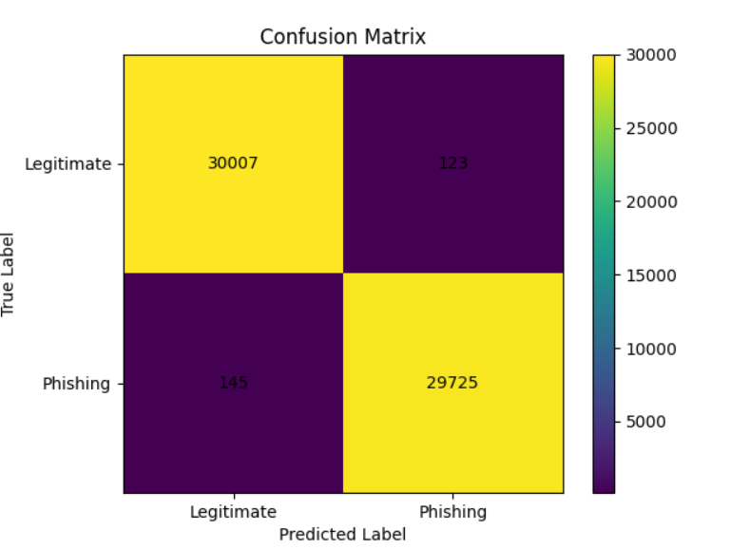
Figure 4: BERT model confusion matrix.

Out of 60,000 evaluated samples, 268 were misclassified. The classification report showed precision, recall, and F1-score rounded to 1.00 for both classes, so the exact accuracy value is also reported.

6.4 Full System Quantitative Results
The full implemented system was evaluated on 1,000 external test cases, including 500 legitimate samples and 500 phishing samples. The test set included real-world messages, malicious URLs, legitimate messages, and edge cases. The evaluation measured the final system behavior, including AI classification, URL analysis, identity checks, decision logic, and user-facing results.

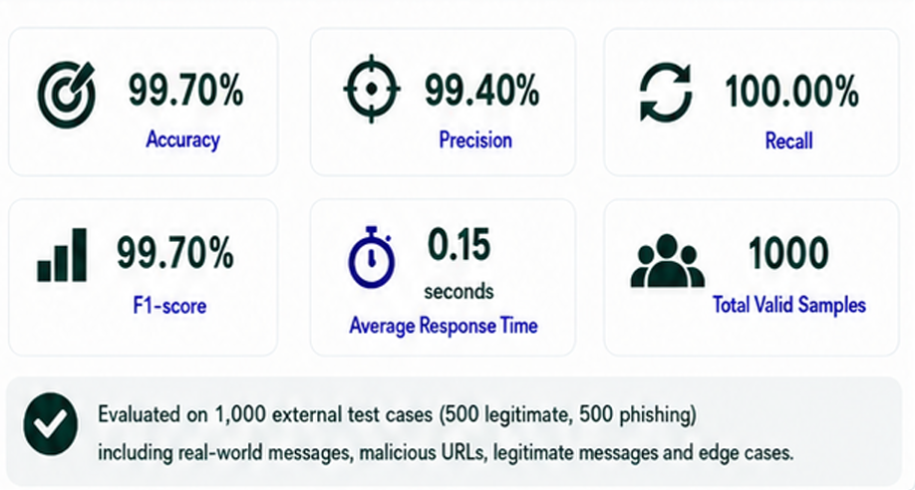
Figure 5: Full system quantitative evaluation results.

6.5 Conclusions From the Evaluation Results
The evaluation results show that both the BERT model and the complete MsgGuard system performed strongly. The BERT model achieved approximately 99.55 percent accuracy on 60,000 evaluated samples, with 268 total misclassifications. These results support the use of BERT as the main AI classification component in the system.
The full implemented system was also evaluated on 1,000 external test cases, including legitimate messages, phishing messages, malicious URLs, and edge cases. The full system achieved 99.70 percent accuracy, 99.40 percent precision, 100.00 percent recall, and a 99.70 percent F1-score, with an average response time of 0.15 seconds.
The difference between the two evaluations is important. The BERT evaluation measures only the trained AI model, while the full system evaluation measures the complete pipeline, including AI classification, URL analysis, identity checks, decision logic, and user-facing result generation. Together, these results show that the implemented system is both accurate and practical for real-time mobile use.
The results also support the hybrid design decision. BERT provides strong text-based phishing detection, while the identity checks add explainable domain-related evidence. This combination helps the system provide not only a classification, but also reasons that can help the user understand why a message or URL is considered legitimate, suspicious, or phishing.

7. Project Conclusions
The Phase B implementation achieved the main goal of building a working phishing-detection system. MsgGuard includes a mobile application, a Flask backend, a fine-tuned BERT model, and identity-based verification checks. The system provides both a classification and a short explanation, which makes it more useful for ordinary users than a black-box label alone.
The project demonstrates the value of combining AI-based analysis with identity-based verification. BERT is useful for detecting suspicious message and URL patterns, while WHOIS domain age verification, IP geolocation, and brand-domain matching provide explainable domain-level evidence. This combination supports practical phishing detection because it allows the system to return both a final result and understandable reasons.
The evaluation results also support the implemented design. The BERT model achieved strong performance on the model evaluation dataset, and the full system evaluation showed strong results on external test cases. These results indicate that MsgGuard can provide accurate and understandable phishing detection in a mobile-focused workflow.
Future work should focus on expanding the brand-reference database, improving deployment stability, testing the system with more real-world mobile users, improving safe logging and monitoring, and adding more continuous feedback mechanisms. These improvements would move MsgGuard from an academic prototype toward a more robust real-world tool.

8. References
[1] Nguyet Q., Ali S., Ondryj K. Deep Learning for Phishing Detection: Taxonomy, Current Challenges, and Future Directions. IEEE Access, 2022. https://doi.org/10.1109/ACCESS.2022.3151903
[2] Maruf A., Khin L., Alamgir H. Intelligent phishing detection scheme using deep learning algorithms. Journal of Enterprise Information Management, 2020. https://www.emerald.com/jeim/article/36/3/747/203279/Intelligent-phishing-detection-scheme-using-deep
[3] Samer Atawneh, Hamzah Aljehani. Phishing Email Detection Model Using Deep Learning. Electronics, 12(20), 4261, 2023. https://www.mdpi.com/2079-9292/12/20/4261
[4] Cagatay Catal, Gorkem Gul, Bider T. Applications of Deep Learning for Phishing Detection: a Systematic Literature Review. Knowledge and Information Systems, 2022. https://pmc.ncbi.nlm.nih.gov/articles/PMC9125357/
[5] Sultan Asiri, Yang Xiao, Saleh Alzahrani, Tieshan Li. PhishingRTDS: A Real-time Detection System for Phishing Attacks Using a Deep Learning Model. Computers and Security, 2024. https://www.sciencedirect.com/science/article/abs/pii/S0167404824001445
[6] Bryan Lim, Roman Huerta, Alejandro Sotelo, Anthonie Quintela, Priyanka Kumar. EXPLICATE: Enhancing Phishing Detection through Explainable AI and LLM-Powered Interpretability. arXiv, 2025. https://arxiv.org/abs/2503.20796
[7] Saba Aslam, Hafsa Aslam, Arslan Manzoor, Chen Hui, Abdur Rasool. AntiPhishStack: LSTM-based Stacked Generalization Model for Optimized Phishing URL Detection. arXiv, 2024. https://arxiv.org/abs/2401.08947
[8] Qazi Haq, Iftikhar A. Detecting Phishing URLs Based on a Deep Learning Approach. Applied Sciences, 2024. https://www.mdpi.com/2076-3417/14/22/10086
[9] Anish Rawla, Preeti et al. Detection of Phishing Attacks in PhiUSIIL Dataset Using Deep Learning. Procedia Computer Science, 2025. https://www.sciencedirect.com/science/article/pii/S1877050925011007
[10] Dinnillah A.H., Widiarto M., Wijaya A. Robust Phishing Detection Using Random Forest with Isolation Forest Based Outlier Filtering. IJACI, 2025. https://journal.cendekiajournal.com/ijaci/article/view/16

Appendix A - User Guide

A.1 Introduction
This guide is intended for regular users of the MsgGuard mobile application. It explains the normal successful use flow of the system and how to understand the result. The user does not need cybersecurity knowledge in order to use the application.

A.2 How to Analyze a Suspicious Message or URL
1. Open the MsgGuard application or share suspicious content to MsgGuard from another mobile application.
2. Paste or submit the suspicious message or URL.
3. Press the analyze button.
4. Wait until the analysis is completed.
5. Read the final classification shown by the application.
6. Review the risk score and short explanation.
7. Avoid opening the link if the system marks it as suspicious or phishing.

A.3 Understanding the Result
- Legitimate means the input did not show strong phishing indicators.
- Suspicious means the system found one or more risk indicators and the user should be careful.
- Phishing means the input appears malicious or strongly risky.
- The explanation lists the main reasons, such as suspicious wording, new domain, brand mismatch, or hosting-origin inconsistency.
The explanation is meant to help the user understand the warning rather than only seeing a technical score. If the result is suspicious or phishing, the safest action is to avoid opening the link and avoid entering personal details.

A.4 User Help
The application guides the user by showing clear result messages and short explanations. The recommended behavior is to avoid interacting with content marked as suspicious or phishing.

Appendix B - Maintenance Guide

B.1 System Environment
- Backend language: Python.
- Backend framework: Flask.
- Frontend framework: React Native with Expo.
- AI component: fine-tuned BERT model.
- Identity checks: WHOIS lookup, IP geolocation, and brand-domain matching.
- Database: MongoDB for project-related data storage and future data management.
- Repository: https://github.com/Eleia522000/phishing-ai-detector

B.2 Running the Backend
1. Clone the Git repository.
2. Create and activate a Python virtual environment.
3. Install the required Python dependencies from the project requirements file.
4. Place the trained BERT model files in the expected model directory.
5. Configure any required API keys or environment variables for WHOIS and IP geolocation services.
6. Run the Flask application.
7. Verify that the analyze endpoint returns a valid JSON response.

B.3 Running the Mobile Application
1. Install Node.js and Expo tools if they are not already installed.
2. Navigate to the React Native application directory.
3. Install the project dependencies.
4. Configure the backend API address used by the application.
5. Run the application with Expo on an Android device or emulator.
6. Submit a test message and confirm that the result is displayed.

B.4 Updating the System
- To update the BERT model, retrain or replace the model files and update the backend model path if needed.
- To update brand-domain matching, modify the brand reference list and test known legitimate and phishing examples.
- To update identity checks, modify the relevant backend module while keeping the JSON response format stable for the mobile app.
- To update the frontend, keep the backend field names consistent or update the response parsing logic.

B.5 Recommended Future Maintenance
- Evaluate the complete hybrid system using a labeled test set processed through the Flask endpoint.
- Monitor false positives and false negatives and update thresholds when necessary.
- Expand the brand-domain reference database.
- Add logging for safe debugging while avoiding storage of sensitive user data.
- Document any future model or API changes in the repository.

